LAB SESSION 08
LOGICAL INSTRUCTIONS
- Write a program to find the highest number among the following:
68h, 87h, 96h, 45h, 75h
Source Code:
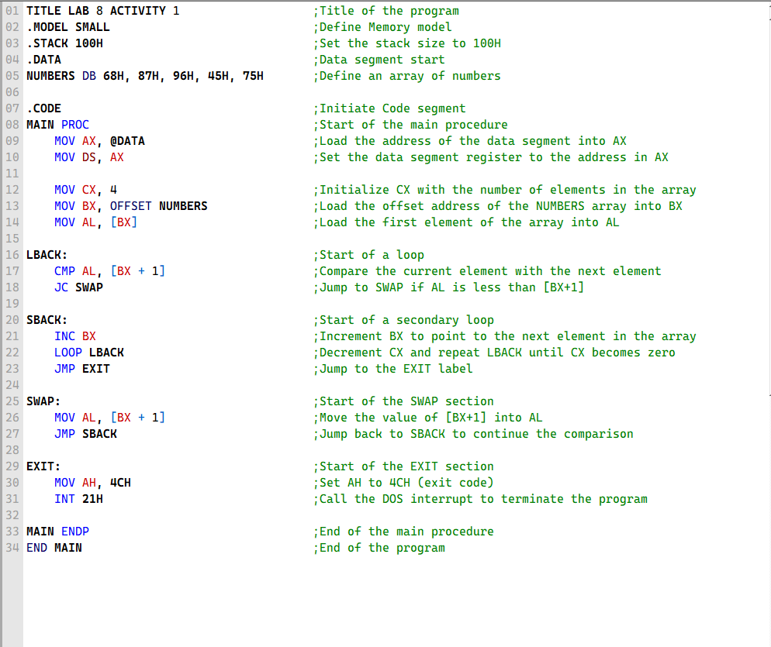
OUTPUT:
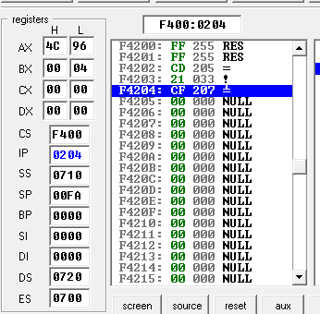
- Write a program to Arrange the following numbers in ascending order.
58h, 37h, 96h, 45h, 25h
Source Code:
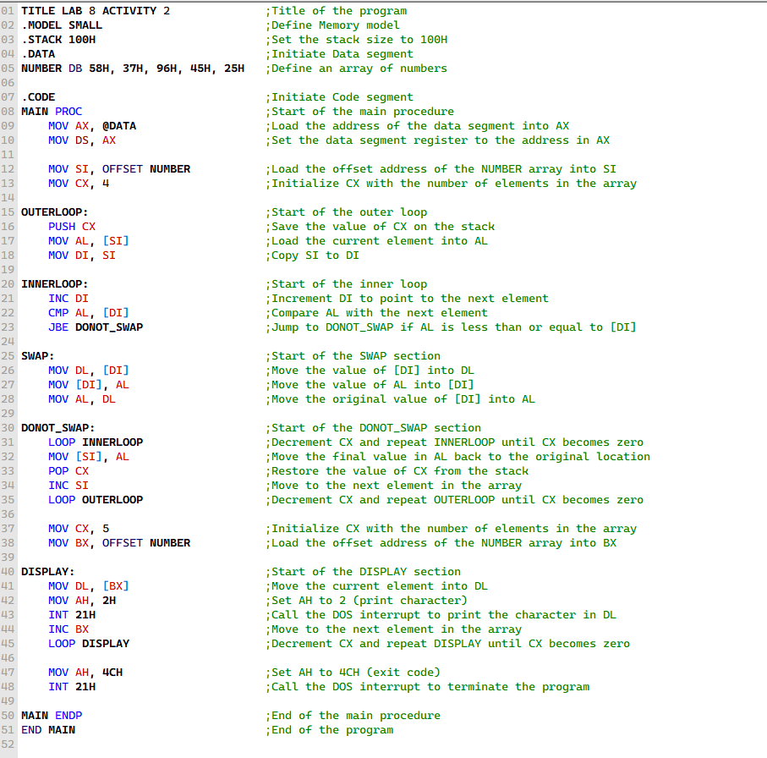
OUTPUT:
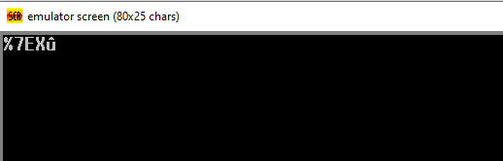
- Write a program to find the highest temperature from the following set of temperatures:
+13, +29, -10, -14, +18, -9, +12, -19, +20, -5
Source Code:
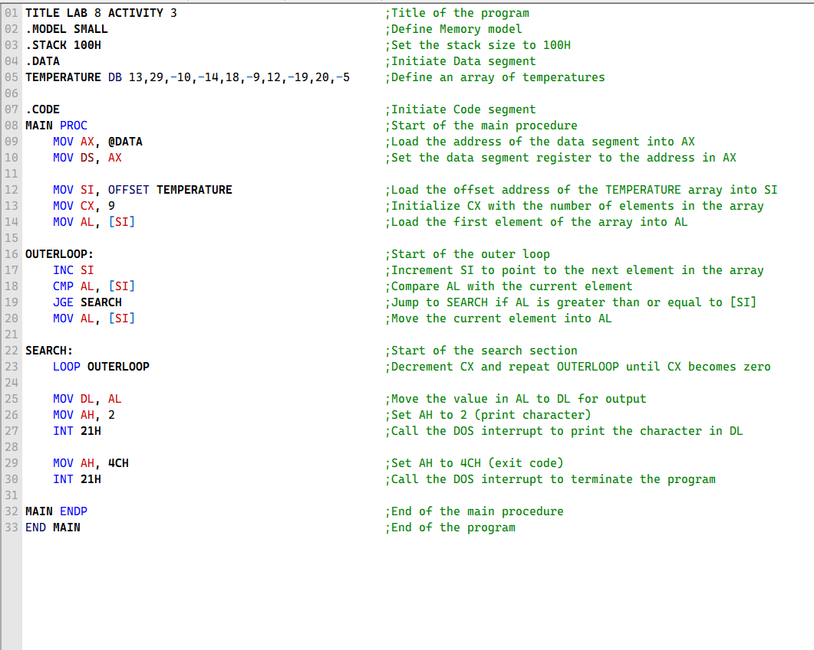
OUTPUT:
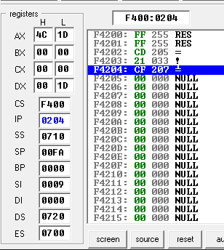


In ASCII Code:
029 = 1D = .

- Write a program to convert alphabets of your first name from lowercase to uppercase. The first name should be provided in the form of array.
For example, the first name is “momin”. It should be defined as:
.DATA
First_name db ‘momin’
Source Code:
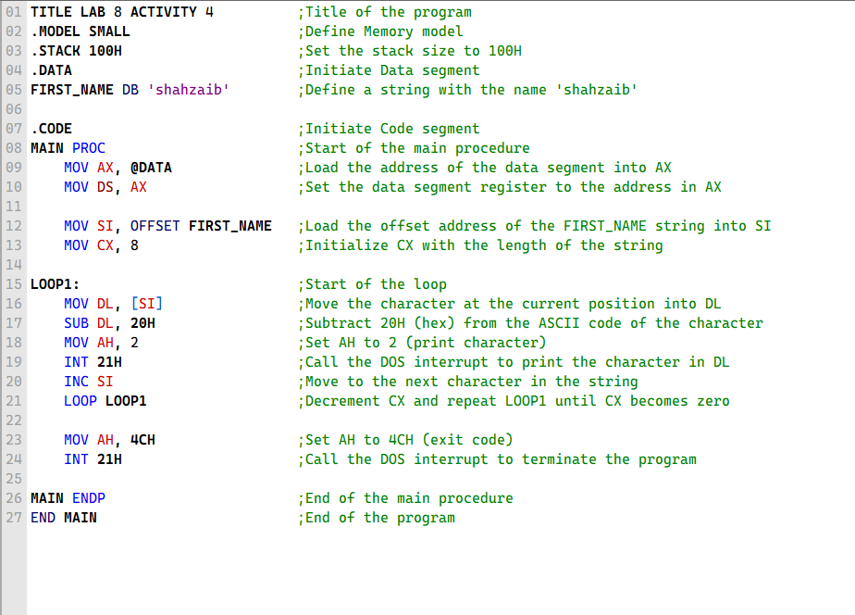
OUTPUT:
